Application for the

EuroSpeleo Protection Label FSE 2023

Ref: FSE/ECPC/ESPL_Application-Form-2023_v1

Name and acronym of the project:
………………………………………………………………………………………………………..

Beneficiary organisation (Name, Country, Full Address, Contact): …………………………………………………………………………………………………………
…………………………………………………………………………………………………………
…………………………………………………………………………………………………………

Person in charge of the project (Name, e-mail, telephone):
…………………………………………………………………………………………………………

Person in charge of the follow-up of the ESPL application (Name, e-mail, telephone)
…………………………………………………………………………………………………………

Organisation representing your country in the FSE and establishing the supporting letter:
…………………………………………………………………………………………………………

Bank details:
IBAN………………………………….......................... BIC……………………………….........
Bank Name:
Bank Address:
Account Holder name:

Place of project implementation:
…………………………………………………………………………………………………………

Key dates of the project (i.e. maximum 3 activities important for project’s progress and outreach):
…………………………………………………………………………………………………………
…………………………………………………………………………………………………………
…………………………………………………………………………………………………………

Expected results and long-term integrated ecological sustainability of your project?
…………………………………………………………………………………………………………
…………………………………………………………………………………………………………
…………………………………………………………………………………………………………

Form to be sent by e-mail before the 30th of April 2023 to: protection@eurospeleo.eu

A project proposal consists of:

1. The Application Form that must be filled in completely and with correct data.
2. Presentation of the protection relevant needs in the context of European Speleological Charta for
Cave Protection (FSE) and implementation steps (250 words);
3. Expected results of the project and long-term integrated ecological sustainability (200 words);
4. Involvement of cavers, co-organisations, partners and stakeholders (100 words);
5. Media and public outreach (50 words);
6. Project Budget (in EUR) with a breakdown for main budget categories (i.e. income, travel, equipment,
consumables, other):
7. A letter from the national speleological organization, member of the FSE, certifying its support for the
project.

All points are mandatory. Failure to provide any information requested will result in project rejection.
Further explanations may be found in the ESPL Application-Guidelines 2023.
(https://www.eurospeleo.eu/ECPC/espl/)

Note: All documents need to be provided in either pdf or doc format.

EuroSpeleo Protection Label is supported by the FSE Partners:

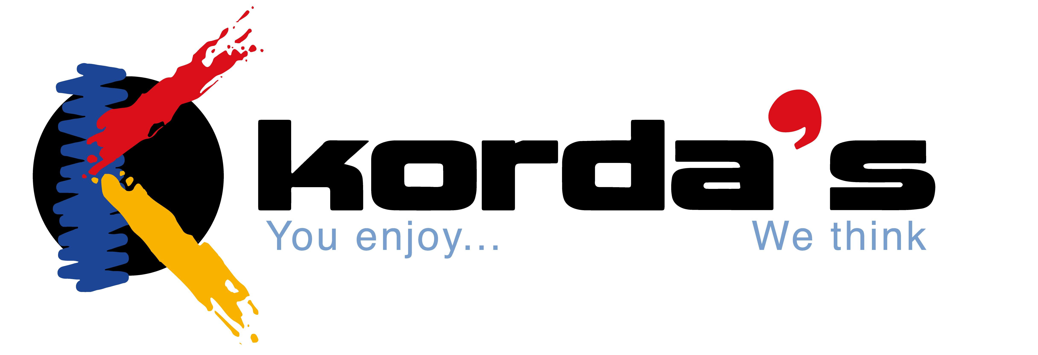
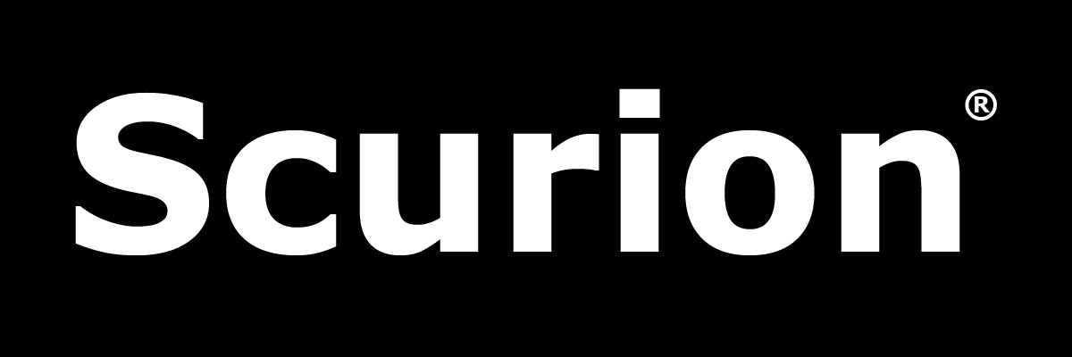

Aventure Verticale Equipment Korda’s Ropes Scurion Lamps Wikicaves - Grottocenter

