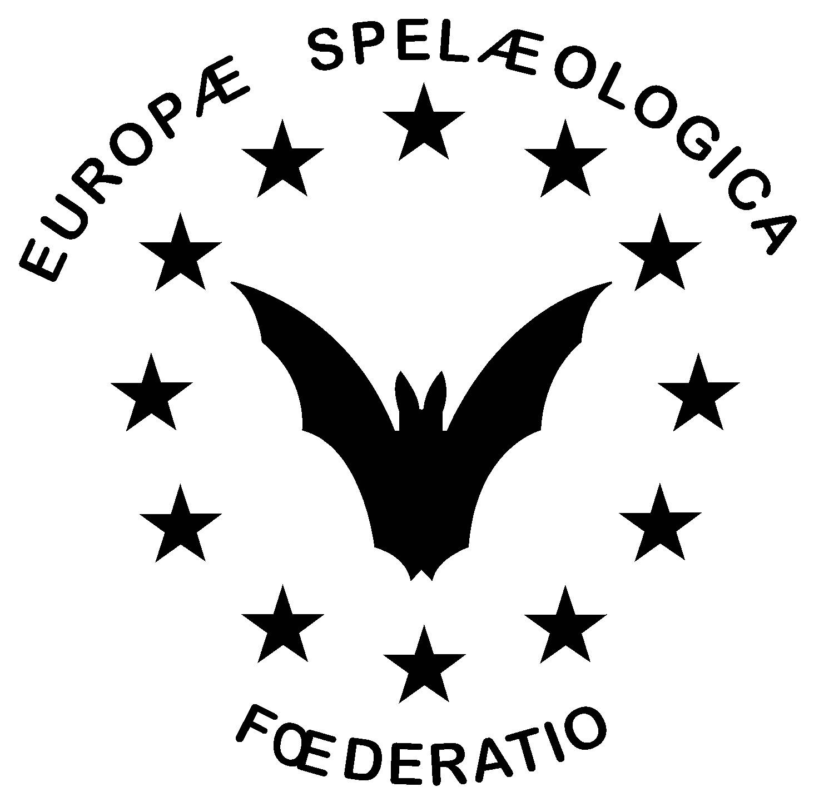 |  | FEDERATION  SPELEOLOGIQUE  EUROPENNE |  | EuroSpeleo Projects  Application form cover  Rev. 01/2022
To be filled only in English/French. Form to be sent via your national FSE delegate or national organization by email at least 3 months before the beginning of the activity. If only applied for a financial grant, this is reduced to 2 month.
For questions please contact us at: contact@eurospeleo.org.
By sending this application form applicants subscribe to the ESP Regulations. With providing personal data through this application form to FSE you agree that the data are filed by FSE. The data will only be processed in anonymous form and will only be forwarded by FSE to its Official partners to ensure sponsoring.
- Supporting National Speleological Organization
- Association/Club organizing and applying for the project with webpage
- Contact of responsible person
Name:
Address:
E-Mail:
Phone:
- Proposed activity
Name of the activity:
Type of activity:
Date dd/mm/yyyy (from-to):
Exact place & region :
Project website :
No. of expected participants (range):
Number of organizers:
Language(s):
- Support applied for:
Available items
A: AV 400 Euro equipment from a selected list of AV. Subject of approval by AV!
B: 200 m of Korda’s rope
C: Scurion set 900 LED Lamp
D: FSE financial grant (min 400 Euro)
Please indicate your preference by priority (for example D/C/B/A):
1st Choice:
2nd Choice
2rd Choice:
4th Choice
Please specifiy here :
Grant ammount applied for in Euro :
Korda’s rope prefered diameter in mm :
Scurion lamp preference of color (black, blue, red, green):
- Person where to send the equipment. Items can not be sent to places outside of Europe. All import duties must be covered by the applicant. Prefered is an address within the EU.
Name:
Address:
E-Mail:
Phone (mandatory):
- Bank details for grant payment
Bank Name:
Bank account holder:
IBAN:
BIC/SWIFT:
- Participants per country:
Please list 3 participating contact persons per country (or fewer if there are fewer participants for some countries). Please note that participants need to be physically present - any reason of absence does not matter. Citizenship counts, not residential address. FSE may request an updated participant list before the shipment of sponsoring items is dispatched.
Country | Total participants  per country |  | Names |  | E-mail
- Supporting documents, please add to this form
Thank you for attaching a description (Word format) of about 6 pages on:
- Project objectives and area or location
- List of participants and partner organizations
- Financial budget
Please explain how does your project contribute to the guiding headline “Explore, Understand, Protect” with the following criteria :
Criteria | Explanation
Innovation & Documentation | New exploration areas, areas not documented, difficulty of area, subjects not previously covered, new meetings or congress subjects, research initiatives, level of documentation and publication of results
Science | Content for karst & cave studies, ie for geology, hydrology and biodiversity, archaeology, paleoclimate,..
Diversity | Number of nations, gender diversity, openness of the project, inclusiveness of approach
Partnerships | Inclusiveness for local partners or the population in the area, cooperation with institutions or other Non-Government (NGO) and Government organisation or Civil Society Organisations (CSO)
Education & Conservation | Training local partners, facilitation of knowledge exchange, protection and conservation activities, publications raising awareness for conservation in the area
Please have also a look on the EuroSpeleo Projects regulations, section 4.

